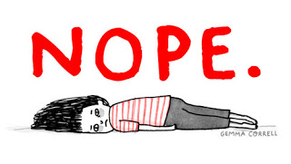  - The Stages of change  precontemplation  Not Ready  People at this stage do not intend to start the healthy behavior in the near future (within 6 months), and may be unaware of the need to change. People here learn more about healthy behavior: they are encouraged to think about the pros of changing their behavior and to feel emotions about the effects of their negative behavior on others.  Precontemplators typically underestimate the pros of changing, overestimate the cons, and often are not aware of making such mistakes.  One of the most effective steps that others can help with at this stage is to encourage them to become more mindful of their decision making and more conscious of the multiple benefits of changing an unhealthy behavior. | Ignorance is bliss!  ____  “I don’t have a problem.”  ____  “Everyone else has a problem.”  ____  “I’m not ready to change.”  ____  “Don’t tell me I have a problem! You are the problem!”  WHAT PRECONTEMPLATION STATEMENTS HAVE YOU HEARD LATELY?

