D

LSI-R Feedback Wheel

1. Use the Feedback Wheel to summarize information and provide feedback to the client.
2. Place the wheel in front of the client and fill it in as you are talking.
3. Fill in the client’s most recent offenses in the center of the wheel.
4. Summarize the strengths by focusing on protective factors.
5. Summarize the three major challenges or priority domains and risk factors in relation to the offenses committed. Summarize the incentives.

Your Organization

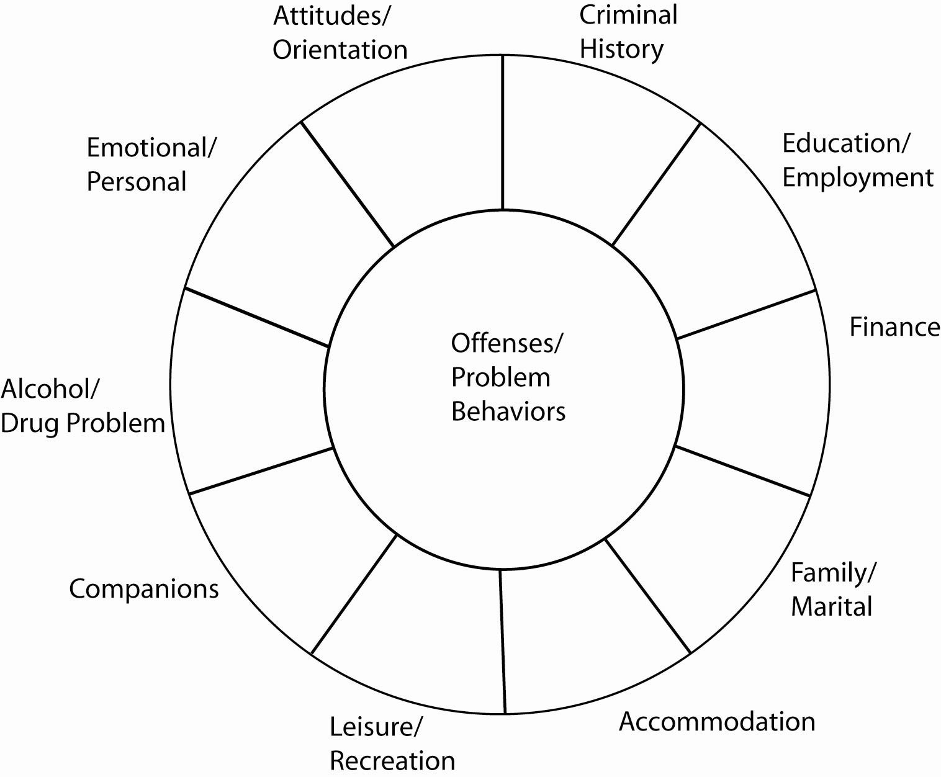

[Date]

How to use the Feedback Wheel