DRUG PROBLEM?
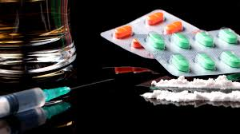 |  | EVER (#38)  SCORE when the following applies:  - HEAVY USE  - NEGATIVE IMPACT (work, school, family, health, finances, etc.)  - POSITIVE UA’S  - REVOCATIONS/VIOLATIONS  - DUI’s  - LAW VIOLATIONS  - AMOUNT, FREQUENCY, TYPES OF DRUGS USED  - LABELS SUCH AS “ADDICT,” “DRUG ABUSER,” “DEPENDENT,” “DRUG ABUSE,” etc.

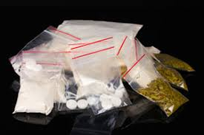
CURRENT (#40)
            - WITHIN THE PAST YEAR
            - IN2: LAST YEAR WITHIN THE COMMUNITY or OVER THE LAST YEAR (INCARCERATED > 2 YEARS)
            - IF/THEN: If #40, THEN #38 and AT LEAST ONE ITEM FROM #41 to 45 MUST BE SCORED
            - VALID MEDICAL MARIJUANA CARD: NO SCORE
            - RATE, then SCORE
0: Use > 2x per week in the past year, drug-
related arrests, withdrawals, drug
dependency, etc.
1: Use 2x per week or less in the past year;
drug-related arrests, withdrawals, drug
dependency, etc.
2: Rare or infrequent, minimal use in past year,
no more than three slips (isolated), no full
relapse
3: No use in the past year
A HISTORY OF DRUG ABUSE IS A RISK FACTOR FOR CRIMINAL BEHAVIOR. EVEN THOUGH A DEFENDANT REPORTS NO PROBLEMS WITH DRUG ABUSE, THE FINAL DETERMINATION IS MADE BY THE INTERVIEWER.

